Icon Examples
- Building Block #1: Data Management
  - An excel spreadsheet or calculator +equations
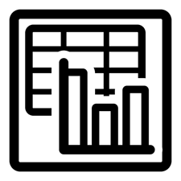
- Building Block #2: EVSE Standards and Communications Protocols
  - Something to denote a rule or certification, a blue ribbon...

- Building Block #3: Charging Infrastructure
  - A charging station with an EV plugged in
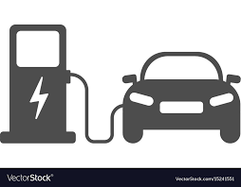
- Building Block #4: Tariff Design
  - Maybe a simple $/kWh with a circle around it
$/kWh

- Building Block #5: Smart Incentive
  - Some that denotes money exchanging hands...some dollar bills

- Building Block #6: Grid Planning and Management
  - some that captures an electricity grid, perhaps some transmission lines and towers
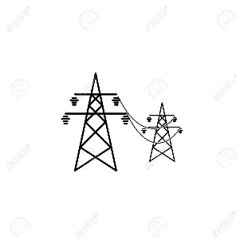
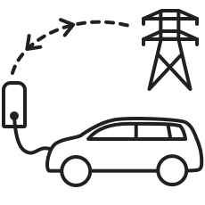

- Building Block #7: Workforce Development
A book, chalkboard, classroom or something else that denotes learning/training



