Site Mockup

Contents
- Home page mockup
- BB #1 Mockup: Version 1
  - A portlet navigates you to key headlines (the blue, bolded, and italicized sentences in the guidebook)
- BB #2 Mockup: Version 2
  - An expandable accordion shows you the subheadings
- Options to add visual interest to the page

Homepage

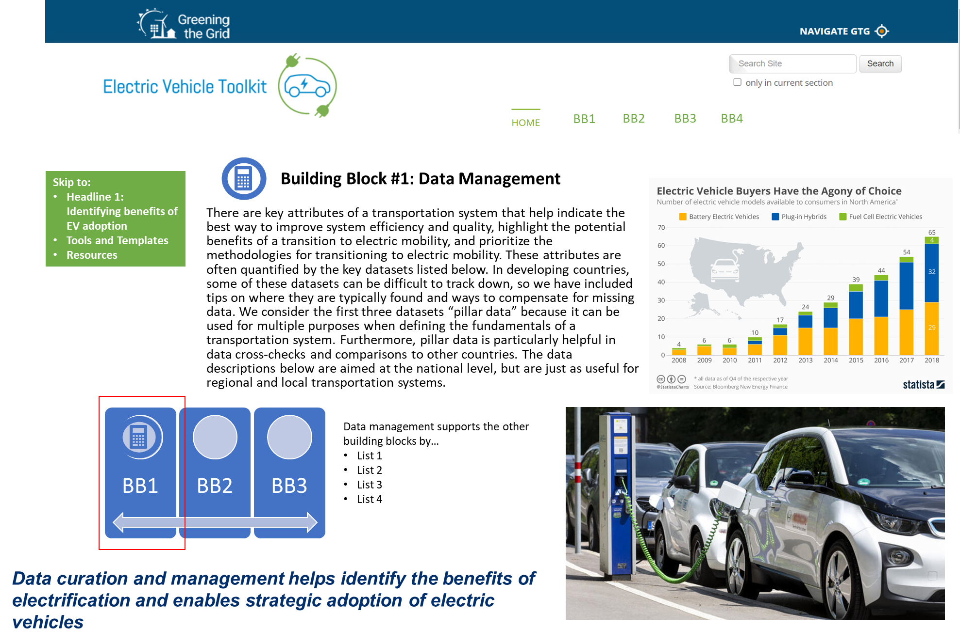

Option 1—with portlet
Transportation Fuel use is pillar data that can be used for multiple purposes. When divided by population, it becomes a basic metric for how energy efficient a transportation system is. It can also be input to numerous models to help estimate the emissions coming from the transport sector, and therefore the air quality impacts of vehicle electrification. Fuel is often imported, making the quantity of fuel used important in macroeconomic, security, and resilience calculations. It can be converted to energy equivalents in order to estimate the increased load (after taking into account the improved efficiency of EVs) that electrifying transportation would add to the grid under various vehicle electrification scenarios.
Fortunately, fuel use is tracked in most countries because it is usually taxed. Therefore, it can usually be located at the Ministry of Revenue or the Ministry of Imports. However, it is often processed and made readily available by the Ministry of Energy.
Vehicle Stock data generally includes the make, model, vehicle type, and model year of every vehicle registered in a country. Vehicle age and average lifespan can be determined by comparing the model year of vehicles to the registration snapshot year. This data is invaluable when determining how many vehicles might be replaced with comparable electric vehicles. It also aids any fleet-based strategy by informing decision makers how many fleet-specific vehicles are in the country.
Vehicle stock is typically collected through a vehicle registration system that is coordinated with registration tax/fee collection. Therefore, the Ministry of Revenue is a good place to start but the Ministry of Transportation may get that data from them. Such databases often need to be supplemented with government fleet vehicles from the ministry in charge of the government fleet, since government fleet vehicle often don’t need to pay taxes or register. Banks are sometimes good sources of vehicle stock data, as they collect it in order to determine wealth when giving out loans. The credit agency Experian and the data company IHS Markit have compiled an international database of vehicle registrations that can be accessed for a fee. Vehicle stock can also be derived from import data if an analyst has a reliable assumption for vehicle life.
Vehicle-kilometers Traveled (VKT) is another pillar of data that can be used for multiple purposes. This metric reports the kilometers that motorized vehicles travel on an annual basis. It broadly reflects the road infrastructure used to support the VKT. When divided by population data, the per-capita VKT reflects how motorized a country’s transport system is. When compartmentalized and divided by fuel consumption it can reveal the average fuel economy of various vehicle categories in a country. Per-capita VKT is a metric that correlates to the GDP of a country and is therefore useful when estimating transportation systems of countries that lack data or when making projections into the future.
VKT is usually tracked by the Ministry of Transportation in order to guide infrastructure buildout and maintenance decisions. This data usually originates as traffic counts on given roads and is aggregated up to the nationwide level. In some cases, the data is not aggregated and needs to be done by the analyst using the data.
Filling missing pillar data. The data sources and format for the three pillar data sets can be more difficult to obtain in developing countries. Fortunately, there are methods to fill in missing data in such instances. Data gaps can be interpolated through simple algebra if one knows vehicle efficiency (VKT/fuel used), annual km travelled per vehicle (VKT/vehicle stock), fuel use per vehicle, and other metrics involving two of the pillar datasets in an equation. An example of this is estimating fuel use based on VMT and average fuel economy based on the equation Fuel Economy=VKT/Fuel Consumption. Furthermore, missing data can be estimated by using proxy data from other countries with economic, cultural, and geographic similarities. For example, one can estimate the per capita transport energy based on population density by aligning them on the line of best fit shown in Figure 3. Another example is using a country’s per-capita GDP in order to estimate its per-capita VMT, based upon the historic relationship between the two explored in Ecola et al. 2014. For detailed case studies that involved filling data gaps, see Jamaica, Tonga, Guam, and US Virgin Islands. It should be noted that there is currently no central database of pillar data for developing countries; such a database would greatly improve the ease and reliability of using proxy data.
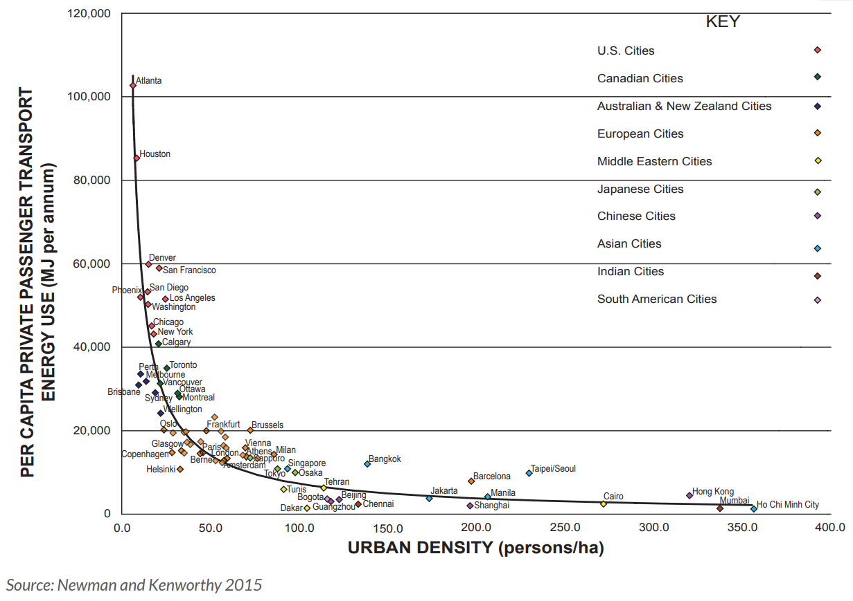
Figure 3. Correlation between energy use per capita in private passenger travel and urban density in global cities (R2=0.86).
Source: Newman and Kenworthy 2015
Mode of travel. While the pillar datasets help define a country’s overall motorization, additional data is needed to better define a transportation system. This information often covers trips that are made by walking, biking, scooter, microtransit, mass transit, taxi, transportation network companies (TNC), carpool, and more. It is often helpful to break this data down by age, gender, and trip type. This data is usually determined through a survey conducted by the national government, often as part of their census. Examples include India’s Census, New Zealand Household Travel Survey, Chilean Household Travel Survey, South African Household Transportation Survey, and the Jamaican Census. Unfortunately, many developing countries haven’t conducted such a survey. For these countries, extrapolations can be made. Transportation mode data from numerous countries are available for a fee on Statista. In general, the means of travel is related to population density and income levels, so extrapolations should be made from countries with a similar population density and income.
Access to home charging is an important indicator for how convenient it will be for EV owners to recharge. Internationally, 50-80% of charging events happen at home, and the lack of home charging availability is often found to be a barrier to EV adoption. However, to the best of our knowledge, no countries have robust datasets on capability to charge at home. The best approximation is the number of houses with garages and car ports, such as the data collected through the American Housing Survey. However, even this data is rare, so another reasonable proxy is the building share of detached and semi-detached houses. This approximation is supported by U.S. data, where the share of housing units with garage or carport (66%) is close to the share of detached houses (62%). This data is often ascertained through property titles/registrations and available through the Ministry of Housing. Another potential source is databases of property titles and real estate listings, some compiled through private companies such as Zillow and Redfin. These could have a variety of property details that serve as good proxies for home charging capability in a number of developing countries.
Gasoline prices are positively correlated with EV purchase rates in the US, and it is reasonable to assume that, when controlling for other factors, this relationship stands globally. Therefore, it is helpful to determine average gasoline prices when deciding in which cities, provinces, or countries to deploy EVs. Gasoline price data is also useful when determining if EV purchase incentives are needed to catalyze a market, and what magnitude. Many Ministries of Energy track gasoline fuel retail prices. For locations where price isn’t tracked, the petroleum excise taxes enable a comparison between areas. This is because oil and gasoline are global commodities, and retail profit margins are relatively uniform in the transparent and competitive retail market. Therefore, the major differences in price come from fuel taxes. These tax rates should be available from the Ministry of Revenue at the federal, state, and local level. It is important to account for all three levels of taxation. Comparisons can be made to most OECD countries based on a dataset compiled by the OECD and distilled by NREL.

Drive Cycle profiles define the distance driven, stops and starts, and acceleration patterns, and geographical travel patterns of specific vehicles. These profiles are used to determine which vehicles would best be replaced by EVs, what the most appropriate equipment is (in terms of vehicle range and EVSE location), and what the economic payback of EV investment will be. Drive cycle profiles can be tracked with common telematics and geo-locating devices such as Geotab or Trip Recorder 747 ProS that simply plug into the on-board diagnostics port or auxiliary power outlet of a vehicle. The data can then be analyzed through models such as NREL’s FASTSim or by analytic services such as ezEV. A meta-analysis and summary of NREL’s drive-cycle analyses for transit buses shows the variety of approaches and related fleet insights into operating temperature, load, and road grade. There are trends that can be discerned from fleet types and functions. In such cases, the drive cycles stored in the FleetDNA database are useful.
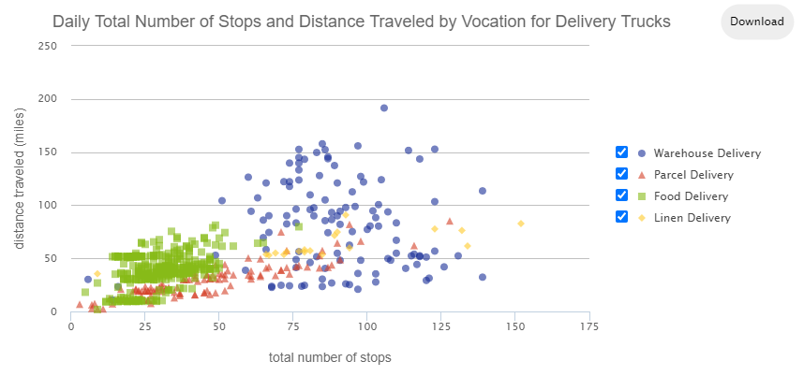
Figure 4: Delivery Truck drive cycle data obtained from geo-locating devices and stored in Fleet DNA
This data helps delivery truck owners determine the necessary battery size and charging infrastructure

Electricity generation fuel mix is data that shows what portion of the electricity is generated by various fuels. This is critical data to have when determining the climate benefits of EV adoption in a given area, as shown in Figure 5 below. This data is usually available from the utility. In countries with numerous utilities, it is often available in aggregated form from the utility regulating body, the Ministry of Energy, or Ministry of Environment.

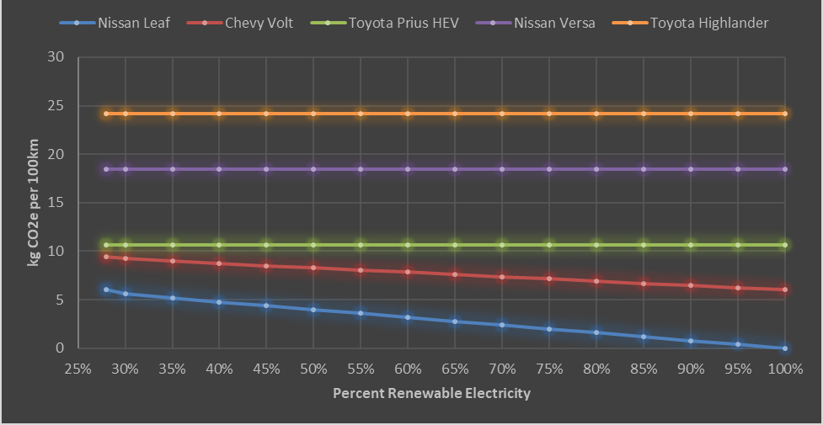
Figure 5. GHG emissions of various vehicles in Mexicali, MX as they increase renewables, given their starting grid mix of 70% natural gas, 2.5% Diesel, and 28% renewable.
Source: Johnson et al. 2020

Data Summary
There is a variety of data that can assess the benefits of and facilitate the strategic adoption of electric vehicles. The most useful and most likely to be found or derived in developing countries is listed in Table 2 below:
Table 2. Summary of Key Transportation Data Valuable for Electrification Efforts
Dataset | Purpose/Use | Source | Probable Keeper* | Alternatives
Transport-ation Fuel use | Defines potential economic & environmental benefits of EVs | Fuel Taxes | Ministry of Energy | Calculate from VKT and fuel economy
Vehicle Stock | Prioritizes vehicles to electrify | Vehicle registration | Ministry of Transportation | Calculate from vehicle imports and expected life
Vehicle-kilometers Traveled | Helps compare electrification with other strategies of increasing transport efficiency | Traffic counts | Ministry of Transportation | Extrapolate from another country/city based on population density or GDP
Mode of travel | Prioritizes vehicles to electrify and compares with other strategies of increasing transport efficiency | Transportation Survey | Ministry of Transportation | Extrapolate from another country/city based on population density
Access to home charging | Indicates how convenient charging will be for population | Housing Survey or Real estate databases | Ministry of Housing, Private Real Estate Websites | Proxies such as detached house type
Gasoline price | Indicates potential economic benefits of EVs | Retail prices | Ministry of Energy | Transportation fuel excise taxes
Drive Cycle profiles | Helps determine which vehicles are suitable for EVs and what equipment is needed | Telematics and Geo-locating devices | Fleet Managers | Fleet DNA
Electricity generation fuel mix | Defines potential economic & environmental benefits of EVs | Electric Utility | Electric Utility | Regulator of Utility or Minnistry of Energy
*Names have been generalized as "ministries" even though they have a wide variety of names.

Option 2—With accordions
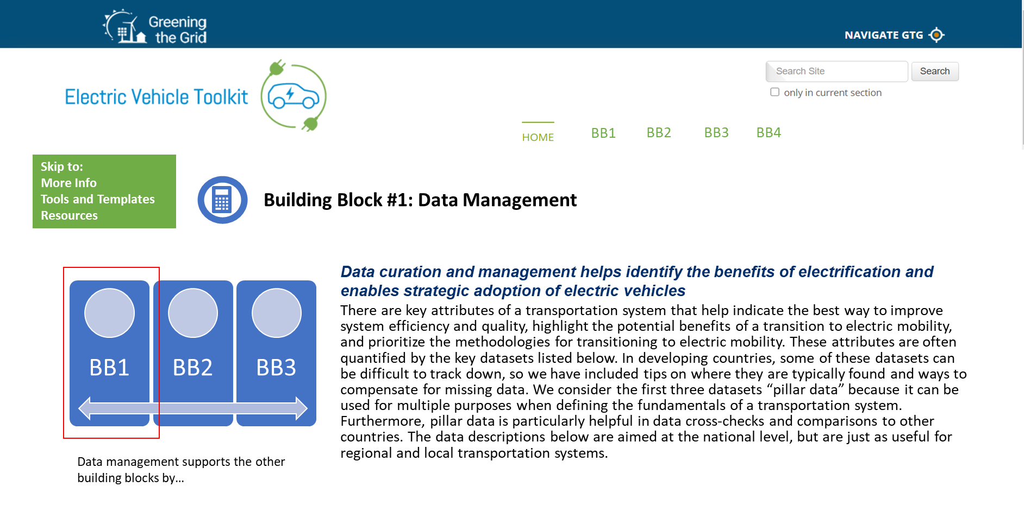
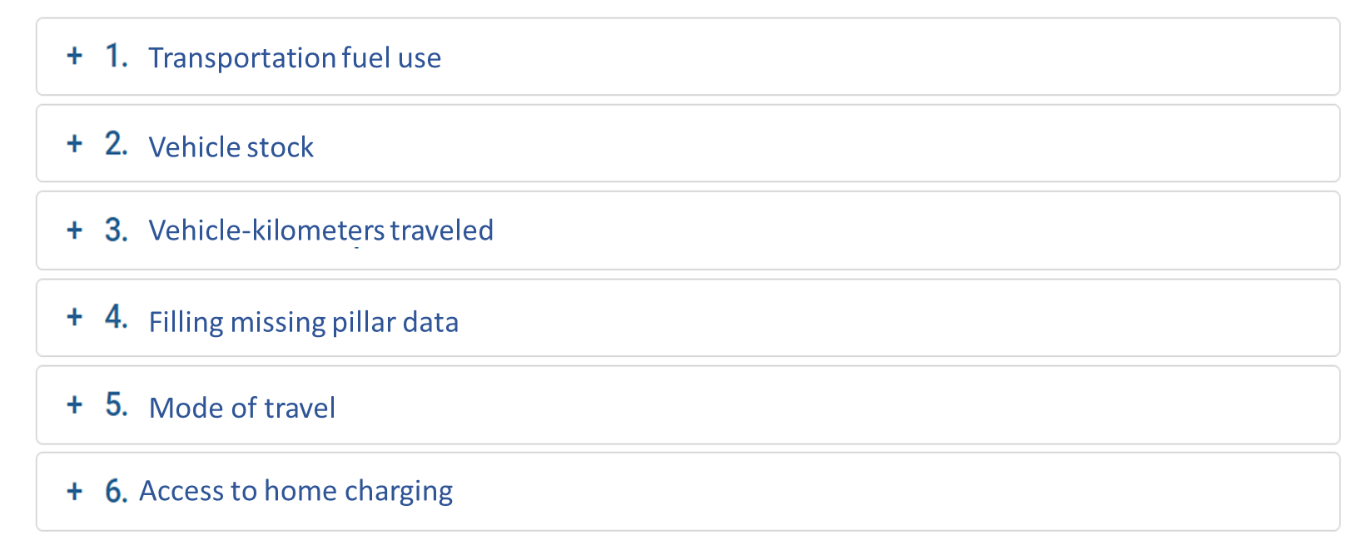
Transportation Fuel use is pillar data that can be used for multiple purposes. When divided by population, it becomes a basic metric for how energy efficient a transportation system is. It can also be input to numerous models to help estimate the emissions coming from the transport sector, and therefore the air quality impacts of vehicle electrification. Fuel is often imported, making the quantity of fuel used important in macroeconomic, security, and resilience calculations. It can be converted to energy equivalents in order to estimate the increased load (after taking into account the improved efficiency of EVs) that electrifying transportation would add to the grid under various vehicle electrification scenarios.
Fortunately, fuel use is tracked in most countries because it is usually taxed. Therefore, it can usually be located at the Ministry of Revenue or the Ministry of Imports. However, it is often processed and made readily available by the Ministry of Energy.
Vehicle Stock data generally includes the make, model, vehicle type, and model year of every vehicle registered in a country. Vehicle age and average lifespan can be determined by comparing the model year of vehicles to the registration snapshot year. This data is invaluable when determining how many vehicles might be replaced with comparable electric vehicles. It also aids any fleet-based strategy by informing decision makers how many fleet-specific vehicles are in the country.
Vehicle stock is typically collected through a vehicle registration system that is coordinated with registration tax/fee collection. Therefore, the Ministry of Revenue is a good place to start but the Ministry of Transportation may get that data from them. Such databases often need to be supplemented with government fleet vehicles from the ministry in charge of the government fleet, since government fleet vehicle often don’t need to pay taxes or register. Banks are sometimes good sources of vehicle stock data, as they collect it in order to determine wealth when giving out loans. The credit agency Experian and the data company IHS Markit have compiled an international database of vehicle registrations that can be accessed for a fee. Vehicle stock can also be derived from import data if an analyst has a reliable assumption for vehicle life.
Vehicle-kilometers Traveled (VKT) is another pillar of data that can be used for multiple purposes. This metric reports the kilometers that motorized vehicles travel on an annual basis. It broadly reflects the road infrastructure used to support the VKT. When divided by population data, the per-capita VKT reflects how motorized a country’s transport system is. When compartmentalized and divided by fuel consumption it can reveal the average fuel economy of various vehicle categories in a country. Per-capita VKT is a metric that correlates to the GDP of a country and is therefore useful when estimating transportation systems of countries that lack data or when making projections into the future.
VKT is usually tracked by the Ministry of Transportation in order to guide infrastructure buildout and maintenance decisions. This data usually originates as traffic counts on given roads and is aggregated up to the nationwide level. In some cases, the data is not aggregated and needs to be done by the analyst using the data.
Filling missing pillar data. The data sources and format for the three pillar data sets can be more difficult to obtain in developing countries. Fortunately, there are methods to fill in missing data in such instances. Data gaps can be interpolated through simple algebra if one knows vehicle efficiency (VKT/fuel used), annual km travelled per vehicle (VKT/vehicle stock), fuel use per vehicle, and other metrics involving two of the pillar datasets in an equation. An example of this is estimating fuel use based on VMT and average fuel economy based on the equation Fuel Economy=VKT/Fuel Consumption. Furthermore, missing data can be estimated by using proxy data from other countries with economic, cultural, and geographic similarities. For example, one can estimate the per capita transport energy based on population density by aligning them on the line of best fit shown in Figure 3. Another example is using a country’s per-capita GDP in order to estimate its per-capita VMT, based upon the historic relationship between the two explored in Ecola et al. 2014. For detailed case studies that involved filling data gaps, see Jamaica, Tonga, Guam, and US Virgin Islands. It should be noted that there is currently no central database of pillar data for developing countries; such a database would greatly improve the ease and reliability of using proxy data.
Figure 3. Correlation between energy use per capita in private passenger travel and urban density in global cities (R2=0.86).
Source: Newman and Kenworthy 2015
Mode of travel. While the pillar datasets help define a country’s overall motorization, additional data is needed to better define a transportation system. This information often covers trips that are made by walking, biking, scooter, microtransit, mass transit, taxi, transportation network companies (TNC), carpool, and more. It is often helpful to break this data down by age, gender, and trip type. This data is usually determined through a survey conducted by the national government, often as part of their census. Examples include India’s Census, New Zealand Household Travel Survey, Chilean Household Travel Survey, South African Household Transportation Survey, and the Jamaican Census. Unfortunately, many developing countries haven’t conducted such a survey. For these countries, extrapolations can be made. Transportation mode data from numerous countries are available for a fee on Statista. In general, the means of travel is related to population density and income levels, so extrapolations should be made from countries with a similar population density and income.
Access to home charging is an important indicator for how convenient it will be for EV owners to recharge. Internationally, 50-80% of charging events happen at home, and the lack of home charging availability is often found to be a barrier to EV adoption. However, to the best of our knowledge, no countries have robust datasets on capability to charge at home. The best approximation is the number of houses with garages and car ports, such as the data collected through the American Housing Survey. However, even this data is rare, so another reasonable proxy is the building share of detached and semi-detached houses. This approximation is supported by U.S. data, where the share of housing units with garage or carport (66%) is close to the share of detached houses (62%). This data is often ascertained through property titles/registrations and available through the Ministry of Housing. Another potential source is databases of property titles and real estate listings, some compiled through private companies such as Zillow and Redfin. These could have a variety of property details that serve as good proxies for home charging capability in a number of developing countries.
Gasoline prices are positively correlated with EV purchase rates in the US, and it is reasonable to assume that, when controlling for other factors, this relationship stands globally. Therefore, it is helpful to determine average gasoline prices when deciding in which cities, provinces, or countries to deploy EVs. Gasoline price data is also useful when determining if EV purchase incentives are needed to catalyze a market, and what magnitude. Many Ministries of Energy track gasoline fuel retail prices. For locations where price isn’t tracked, the petroleum excise taxes enable a comparison between areas. This is because oil and gasoline are global commodities, and retail profit margins are relatively uniform in the transparent and competitive retail market. Therefore, the major differences in price come from fuel taxes. These tax rates should be available from the Ministry of Revenue at the federal, state, and local level. It is important to account for all three levels of taxation. Comparisons can be made to most OECD countries based on a dataset compiled by the OECD and distilled by NREL.

Drive Cycle profiles define the distance driven, stops and starts, and acceleration patterns, and geographical travel patterns of specific vehicles. These profiles are used to determine which vehicles would best be replaced by EVs, what the most appropriate equipment is (in terms of vehicle range and EVSE location), and what the economic payback of EV investment will be. Drive cycle profiles can be tracked with common telematics and geo-locating devices such as Geotab or Trip Recorder 747 ProS that simply plug into the on-board diagnostics port or auxiliary power outlet of a vehicle. The data can then be analyzed through models such as NREL’s FASTSim or by analytic services such as ezEV. A meta-analysis and summary of NREL’s drive-cycle analyses for transit buses shows the variety of approaches and related fleet insights into operating temperature, load, and road grade. There are trends that can be discerned from fleet types and functions. In such cases, the drive cycles stored in the FleetDNA database are useful.
Figure 4: Delivery Truck drive cycle data obtained from geo-locating devices and stored in Fleet DNA
This data helps delivery truck owners determine the necessary battery size and charging infrastructure

Electricity generation fuel mix is data that shows what portion of the electricity is generated by various fuels. This is critical data to have when determining the climate benefits of EV adoption in a given area, as shown in Figure 5 below. This data is usually available from the utility. In countries with numerous utilities, it is often available in aggregated form from the utility regulating body, the Ministry of Energy, or Ministry of Environment.

Figure 5. GHG emissions of various vehicles in Mexicali, MX as they increase renewables, given their starting grid mix of 70% natural gas, 2.5% Diesel, and 28% renewable.
Source: Johnson et al. 2020

Data Summary
There is a variety of data that can assess the benefits of and facilitate the strategic adoption of electric vehicles. The most useful and most likely to be found or derived in developing countries is listed in Table 2 below:
Table 2. Summary of Key Transportation Data Valuable for Electrification Efforts
Dataset | Purpose/Use | Source | Probable Keeper* | Alternatives
Transport-ation Fuel use | Defines potential economic & environmental benefits of EVs | Fuel Taxes | Ministry of Energy | Calculate from VKT and fuel economy
Vehicle Stock | Prioritizes vehicles to electrify | Vehicle registration | Ministry of Transportation | Calculate from vehicle imports and expected life
Vehicle-kilometers Traveled | Helps compare electrification with other strategies of increasing transport efficiency | Traffic counts | Ministry of Transportation | Extrapolate from another country/city based on population density or GDP
Mode of travel | Prioritizes vehicles to electrify and compares with other strategies of increasing transport efficiency | Transportation Survey | Ministry of Transportation | Extrapolate from another country/city based on population density
Access to home charging | Indicates how convenient charging will be for population | Housing Survey or Real estate databases | Ministry of Housing, Private Real Estate Websites | Proxies such as detached house type
Gasoline price | Indicates potential economic benefits of EVs | Retail prices | Ministry of Energy | Transportation fuel excise taxes
Drive Cycle profiles | Helps determine which vehicles are suitable for EVs and what equipment is needed | Telematics and Geo-locating devices | Fleet Managers | Fleet DNA
Electricity generation fuel mix | Defines potential economic & environmental benefits of EVs | Electric Utility | Electric Utility | Regulator of Utility or Minnistry of Energy
*Names have been generalized as "ministries" even though they have a wide variety of names.

Suggestions for visual interest:

- Have the building blocks scroll down to reduce the effect of a small page https://www.eere.energy.gov/islandsplaybook/#phase2
- Have a few lines of text and/or an image that is open already before the item is expanded

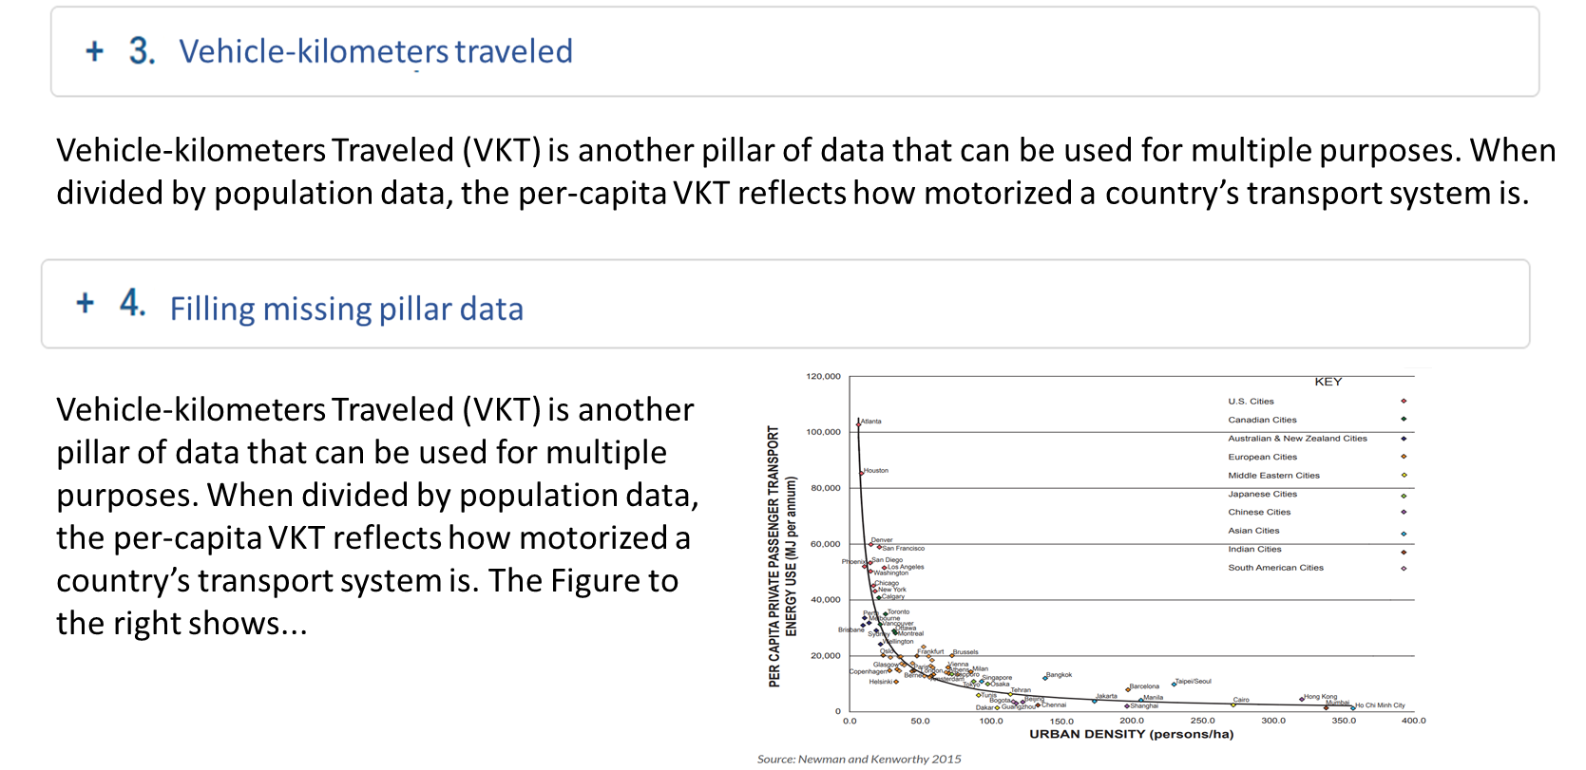
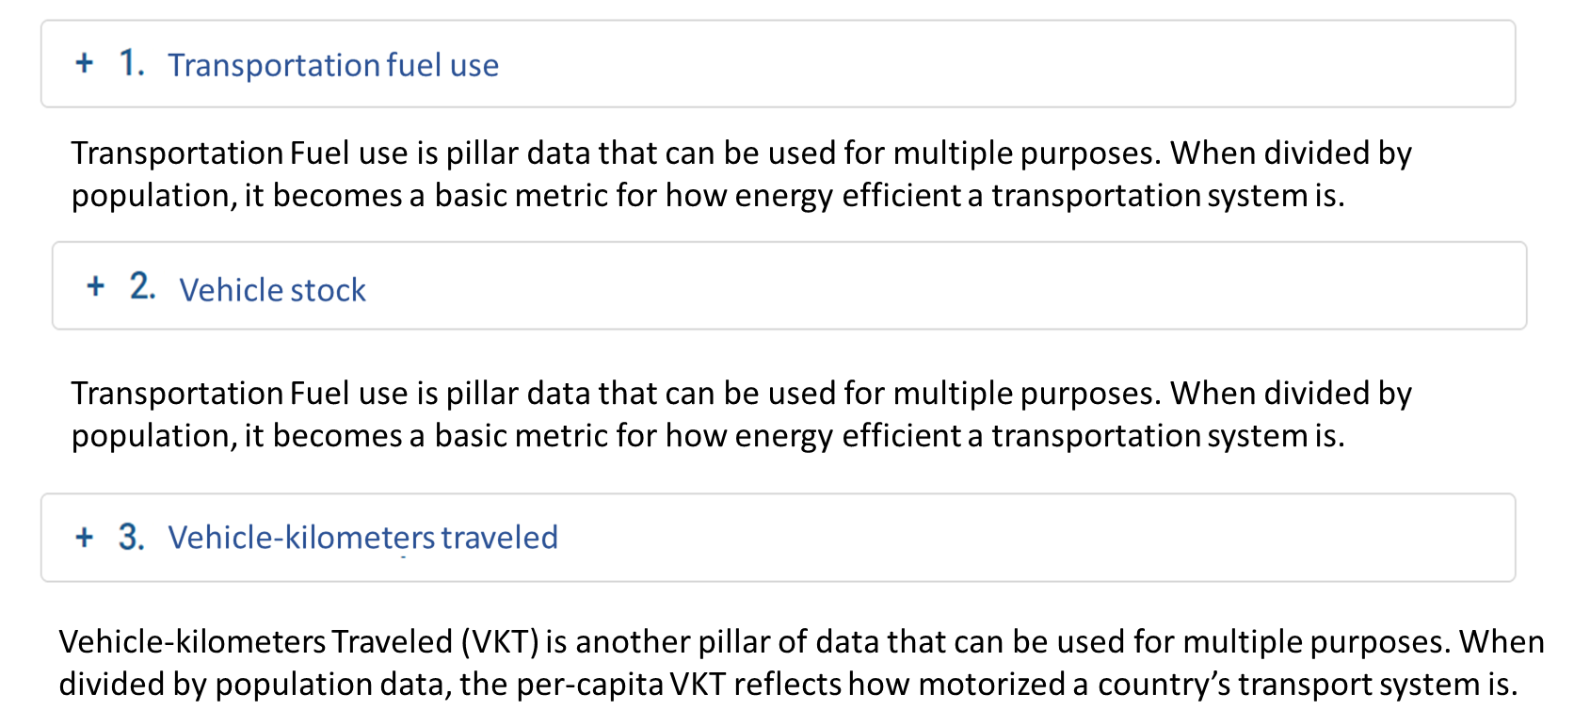
- Image and/or chart at the top of each BB before the expanding list
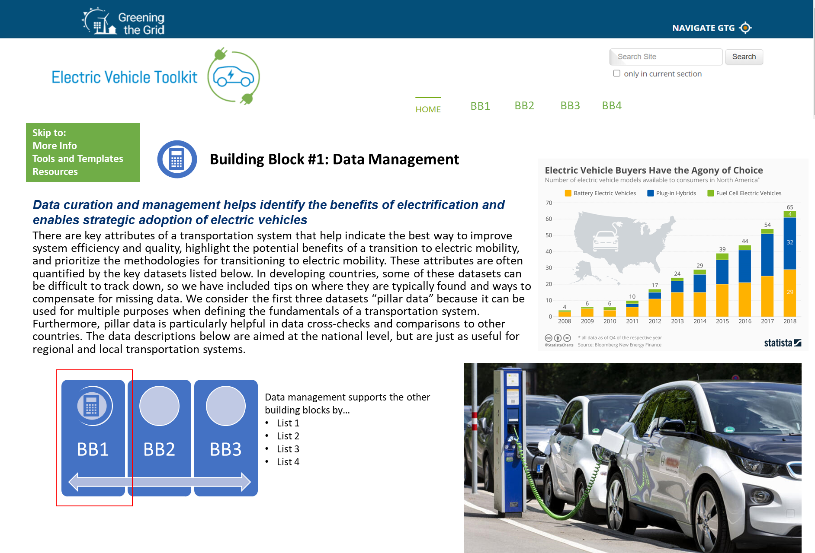

https://www.fueleconomy.gov/feg/evtech.shtml
Throughout this report, we will refer to given government agencies as “Ministry of X” when in fact the name of these agencies varies widely across countries.
https://www.nrel.gov/docs/fy19osti/73380.pdf
https://www.rand.org/pubs/research_reports/RR636.html
https://www.nrel.gov/docs/fy19osti/73380.pdf
https://www.ctc-n.org/system/files/dossier/3b/deliverable_3.3._final_teemp.pdf
Significant similarities include GDP, spatial dispersion, car infrastructure, fuel price, pro-car policies, driving alternatives, activity levels, petroleum resources, domestic car industry, and car culture (https://www.rand.org/pubs/research_reports/RR636.html)
https://www.nrel.gov/docs/fy19osti/73380.pdf
https://www.ctc-n.org/system/files/dossier/3b/deliverable_3.3._final_teemp.pdf
https://www.nrel.gov/docs/fy13osti/57191.pdf
https://www.nrel.gov/docs/fy11osti/52565.pdf
https://islandpress.org/books/end-automobile-dependence
https://www.censusindia.gov.in/2011census/hlo/Data_sheet/India/Transportation.pdf
https://www.transport.govt.nz/mot-resources/household-travel-survey/
www.statista.com/statistics/909952/chile-most-used-transport-mode/
https://www.statista.com/statistics/1116074/distribution-of-transportation-used-to-get-to-work-in-south-africa/
2011 Census of Population and Housing. Table 1.11: Total Population 3 Years Old and Over by Usual Mode of Transportation by Parish. Statistical Institute of Jamaica.
www.statista.com
https://www.sciencedirect.com/science/article/pii/S1361920918301330
https://reader.elsevier.com/reader/sd/pii/S136192091930896X?token=2E23EE314B57AB65D87822D733F6CFE7291F4408CB81F8CA0F870AA71185C7F9D40B08E694BFD5AF98036BC94CEA1AF4
https://www.census.gov/programs-surveys/ahs.html
https://reader.elsevier.com/reader/sd/pii/S136192091930896X?token=2E23EE314B57AB65D87822D733F6CFE7291F4408CB81F8CA0F870AA71185C7F9D40B08E694BFD5AF98036BC94CEA1AF4
https://iopscience.iop.org/article/10.1088/1748-9326/aad0f8/meta
https://afdc.energy.gov/data/10327
A. Brooker, J. Gonder, L. Wang, E. Wood, S. Lopp, and L. Ramroth, “FASTSim: A Model to Estimate Vehicle Efficiency, Cost and Performance,” SAE Tech. Pap. 2015-01-0973, 2015.
https://sawatchgroup.com/ezev.html
Hodge, C. and A. Kotz. Forthcoming. Assessing Candidates for Bus Electrification.
https://www.nrel.gov/transportation/fleettest-fleet-dna.html
https://afdc.energy.gov/files/u/publication/electric_mobility_strategy_mexicali.pdf
https://www.fueleconomy.gov/feg/evtech.shtml
Throughout this report, we will refer to given government agencies as “Ministry of X” when in fact the name of these agencies varies widely across countries.
https://www.nrel.gov/docs/fy19osti/73380.pdf
https://www.rand.org/pubs/research_reports/RR636.html
https://www.nrel.gov/docs/fy19osti/73380.pdf
https://www.ctc-n.org/system/files/dossier/3b/deliverable_3.3._final_teemp.pdf
Significant similarities include GDP, spatial dispersion, car infrastructure, fuel price, pro-car policies, driving alternatives, activity levels, petroleum resources, domestic car industry, and car culture (https://www.rand.org/pubs/research_reports/RR636.html)
https://www.nrel.gov/docs/fy19osti/73380.pdf
https://www.ctc-n.org/system/files/dossier/3b/deliverable_3.3._final_teemp.pdf
https://www.nrel.gov/docs/fy13osti/57191.pdf
https://www.nrel.gov/docs/fy11osti/52565.pdf
https://islandpress.org/books/end-automobile-dependence
https://www.censusindia.gov.in/2011census/hlo/Data_sheet/India/Transportation.pdf
https://www.transport.govt.nz/mot-resources/household-travel-survey/
www.statista.com/statistics/909952/chile-most-used-transport-mode/
https://www.statista.com/statistics/1116074/distribution-of-transportation-used-to-get-to-work-in-south-africa/
2011 Census of Population and Housing. Table 1.11: Total Population 3 Years Old and Over by Usual Mode of Transportation by Parish. Statistical Institute of Jamaica.
www.statista.com
https://www.sciencedirect.com/science/article/pii/S1361920918301330
https://reader.elsevier.com/reader/sd/pii/S136192091930896X?token=2E23EE314B57AB65D87822D733F6CFE7291F4408CB81F8CA0F870AA71185C7F9D40B08E694BFD5AF98036BC94CEA1AF4
https://www.census.gov/programs-surveys/ahs.html
https://reader.elsevier.com/reader/sd/pii/S136192091930896X?token=2E23EE314B57AB65D87822D733F6CFE7291F4408CB81F8CA0F870AA71185C7F9D40B08E694BFD5AF98036BC94CEA1AF4
https://iopscience.iop.org/article/10.1088/1748-9326/aad0f8/meta
https://afdc.energy.gov/data/10327
A. Brooker, J. Gonder, L. Wang, E. Wood, S. Lopp, and L. Ramroth, “FASTSim: A Model to Estimate Vehicle Efficiency, Cost and Performance,” SAE Tech. Pap. 2015-01-0973, 2015.
https://sawatchgroup.com/ezev.html
Hodge, C. and A. Kotz. Forthcoming. Assessing Candidates for Bus Electrification.
https://www.nrel.gov/transportation/fleettest-fleet-dna.html
https://afdc.energy.gov/files/u/publication/electric_mobility_strategy_mexicali.pdf

